Chapter No 2
COMPONENTS OF COMPUTER
INPUT DEVICES
REVISION:
Data: Raw Facts, figures, events and transactions are called data
Information: Meaning full data is called information or processed data is called information”
Computer: Computer is an electronic device which takes some input, process it, and produce output.
Components of computer: Input, Output, CPU

WHAT IS INPUT?
Input is any data or instructions entered to the computer. Input can be in the form of audio, video, graphics and animations and instructions
WHAT ARE INPUT DEVICES?
Any hardware component used to enter data, programs, commands, and user responses into a computer
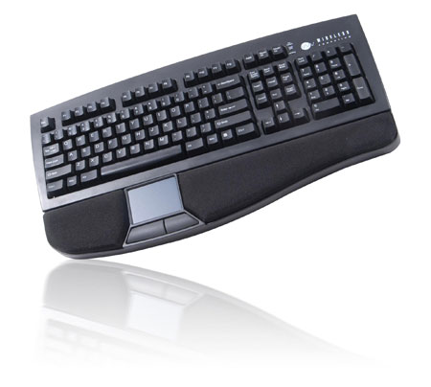
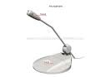
Examples
- Key Board
- Mouse
- Digital Camera
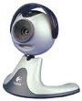
- Webcam
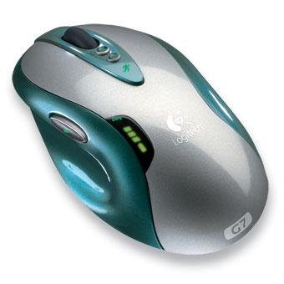
- Scanner etc
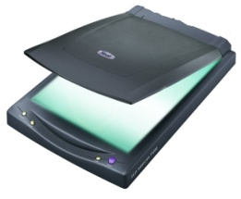

WHAT IS HARDWARE?
The term hardware refers to the physical parts of the computer. Computer hardware is versatile-what it does depends on the computer program you use. All components which are tangible (touchable) are called Hardware
Examples: Mic, Keyboard,Hard Disk, Scanner, Printer etc
WHAT IS SOFTWARE?
Software is the set of instructions (also called a program) that guides the hardware through its job. That tells the computer what to do? And how to do it? All components which are non tangible (Not Touchable) are called software.
Examples: Ms Office, Operating Systems, Adobe photo shop etc

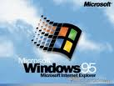

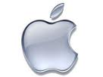
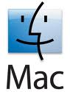

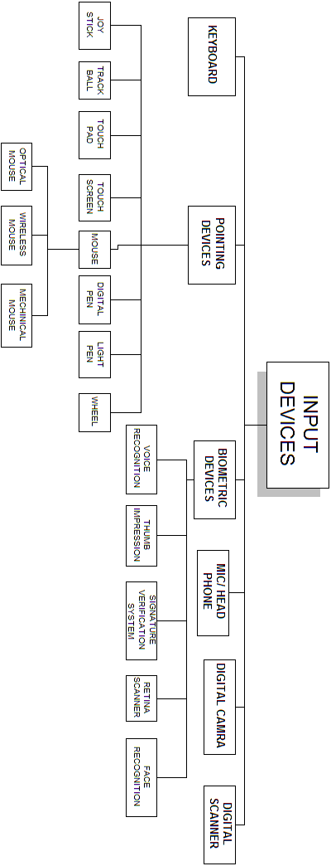

- KEYBOARD
Definition:
“Keyboard is an input device, that contain keys user press to enter data or instructions in to the computer”.
You enter most input data into the computer by using a keyboard. This input method is similar to typing on a typewriter.
Most typewriter and computer keyboards are QWERTY keyboards. The alphabetic keys are arranged so that the upper-left row of letters begins with the six letters Q W E R T Y. Designers of other keyboards claim that their boards are easier to learn than the QWERTY keyboard.
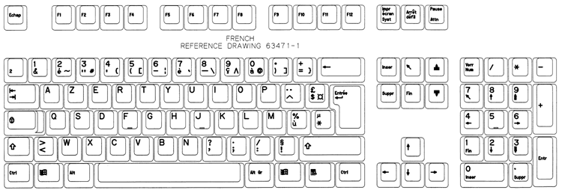
KEYS OF KEYBOARD
Computer keyboards include keys that are designed to perform specific tasks. These keys enable the user to perform complex tasks easily when using the application. For example, many applications use a function key to access online help for the user.
Keyboard keys consist of
- Alphabetic keys
- Numerical keys
- Symbols
- Functional keys
- Extra keys
Alphabetic keys contain alphabets from A-Z & a-z
Numerical keys contain numbers 0-9
Symbols keys contain many symbols like !, @, #, $, % etc
Functional keys contain f1-f12, design for special purpose will discuss latter.
Extra keys contain Esc, Alt, Ctrl, Backspace, Enter etc

- POINTING DEVICES

Definition:
A pointing device is an input device which is used to control a pointer on a screen. Pointer is a small symbol on a screen.
A pointing device is an input interface (specifically a human interface device) that allows a user to input spatial (i.e., continuous and multi-dimensional) data to a computer. CAD systems and graphical user interfaces (GUI) allow the user to control and provide data to the computer using physical gestures — point, click, and drag — for example, by moving a hand-held mouse across the surface of the physical desktop and activating switches on the mouse. Movements of the pointing device are echoed on the screen by movements of the pointer (or cursor) and other visual changes.

2.1) MOUSE
Definition:

“Mouse is an input device that fits under palm of hand and Controls movement of pointer, also called mouse”
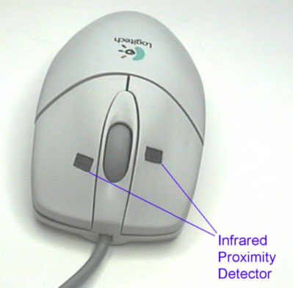
The mouse is a palm-size device with a ball built into the bottom. The mouse is usually connected to the computer by a cable (computer wires are frequently called cables) and may have from one to four buttons (but usually two). Mice come in many shapes and sizes. When you move the mouse over a smooth surface, the ball rolls, and the pointer on the display screen moves in the same direction.
With the mouse, you can draw, select options from a menu, and modify or move text. You issue commands by pointing with the pointer and clicking a mouse button. In addition to minimizing typing errors, a mouse makes operating a microcomputer easier for beginning.
TYPES OF MOUSE
There are three types of mouse
- Mechanical mouse
- Optical mouse
- Wireless mouse
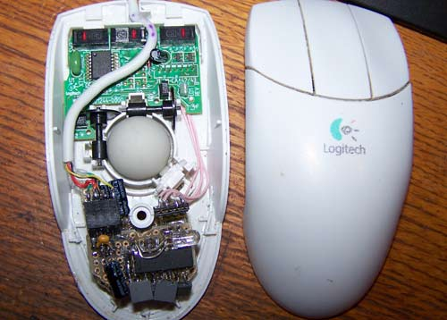

MECHANICAL MOUSE:
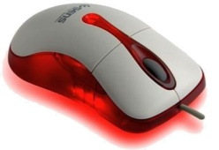
The mouse that contains a metal or rubber ball on its under side. When the ball is rolled in any direction, sensors inside the mouse detect this motion and move the on-screen mouse pointer in the same direction (picture above).

OPTICAL MOUSE:
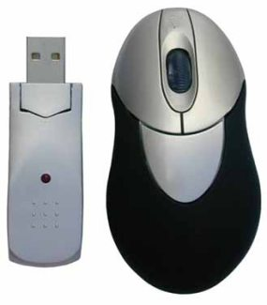
An optical mouse uses a light-emitting (laser) to detect movement relative to the underlying surface.

WIRELESS MOUSE:
Wireless mice usually work via radio frequencies commonly referred to as RF. RF wireless mice require two components to work properly a radio transmitter and a radio receiver.

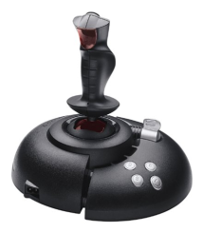
2.2) JOY STICK
A joystick is a pointing device often used for playing games. The joystick has a gearshift-like lever that is used to move the pointer on the screen. On most joysticks, a button on the top is used to select options. In industry and manufacturing, joysticks are used to control robots. Flight simulators and other training simulators also use joysticks.

2.3) TRACKBALL
A trackball is like an upside-down mouse. Used similarly to the mouse, the trackball is frequently attached to or built into the keyboard.
The main advantage of a trackball is that it requires less desk space than a mouse. (Some individuals in the computer industry believe that the mouse will soon be replaced by devices that do not require as much space to use.)
The mouse is not practical for people using a laptop computer in a small space. Early alternatives, such as trackballs clipped to the side of the keyboard, have not proved satisfactory. The IBM ThinkPad replaces the trackball with a red plastic button, called a track point, located in the middle of the keyboard. You move the button with your thumbs.
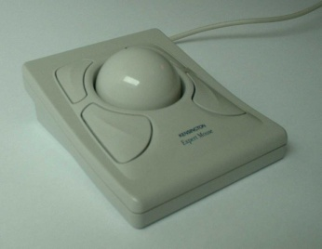
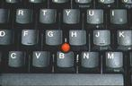

2.4) TOUCHPAD
A touch pad is a device for pointing (controlling input positioning) on a computer display screen. It is an alternative to the mouse. Originally incorporated in laptop computers, touch pads are also being made for use with desktop computers. A touch pad works by sensing the user's finger movement and downward pressure.
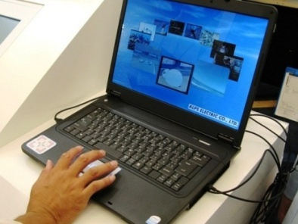

2.5) TOUCHSCREEN
A touch screen is a computer display screen that is also an input device. The screens are sensitive to pressure; a user interacts with the computer by touching pictures or words on the screen.

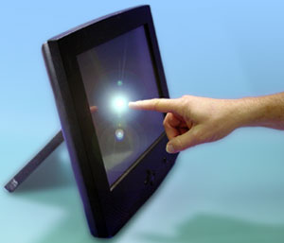

2.6) DIGITAL PEN
A digital pen is a battery-operated writing instrument that allows the user to digitally capture a handwritten note or drawing. Typically, a digital pen comes with a Universal Serial Bus (USB) cradle to let the user upload the handwritten notes to a personal computer (PC).

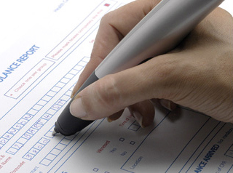
The pen looks like a regular ball-point pen and can be used as such, but requires special digital paper if the user wishes to digitally capture what he has written. A page of digital paper, which can be purchased in traditional pad or sticky-note size, has small dots on it that allow the pen to "see" what has been written.

2.7) LIGHT PEN
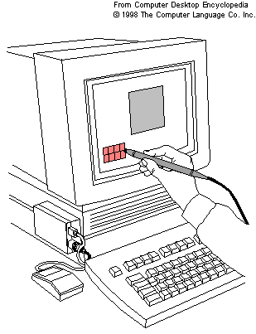
A light-sensitive stylus wired to a video terminal used to draw pictures or select menu options. The user brings the pen to the desired point on screen and presses the pen button to make contact. Contrary to what it looks like, the pen does not shine light onto the screen; rather, the screen beams into the pen. Screen pixels are constantly being refreshed. When the user presses the button, the pen senses light, and the pixel being illuminated at that instant identifies the screen location.

2.8) WHEEL
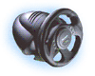
Steering wheels are gaming devices used in driving games. All steering wheel controllers come with a wheel, accelerator, and brake; some steering wheel controllers allow "manual" (i.e., gear-to-gear) shifting, while others only have high-low or forward-reverse options. A whole range of racing wheels have been developed to make the experience of driving more realistic. And with the development of force feedback you can feel the actual resistance particular types of steering have. For example, riding a motorcycle is quite different than flying a helicopter or driving a car or tank.

3) BIOMETRIC DEVICES
A "biometric device" is any device that measures a biological function or trait. it identifies persons seeking access to a computing system by determining their physical characteristics through fingerprints, voice recognition, retina patterns, pictures, weight, or other means.

3.1) VOICE RECOGNITION
A system in which the computer recognizes human speech and transforms the recorded words into computer-readable digitized text or instruction.
The conversion of spoken words into computer text. Speech is first digitized and then matched against a dictionary of coded waveforms. The matches are converted into text as if the words were typed on the keyboard.
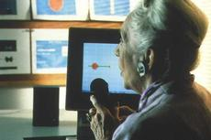

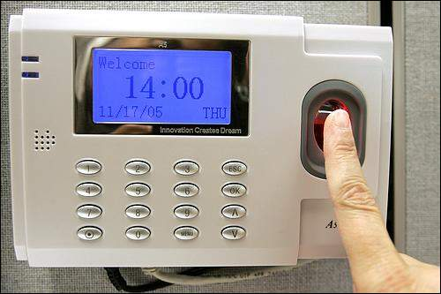
3.2) THUMB IMPRESSION
Biometrics can be defined as an automatic method for identification or identity verification of individuals using physiological or behavioral characteristics.

3.3) SIGNATURE VERIFICATION
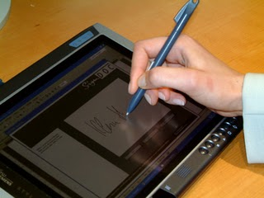
Digital signature unit capture and save signatures as people sign on the LCD touch screens. These signatures can be saved for use to electronically sign documents, customer signature verification for POS transactions, or employee authentication. Get your electronic signature capture system today.

3.4) RETINA SCANNER
Retina scanner is used to map the unique patterns of a person's retina. it uses the unique patterns on a person's retina to identify them.
It is used for authentication and identification purposes. Retinal scanning has been utilized by several government agencies including the FBI, CIA, and NASA. However, in recent years, retinal scanning has become more commercially popular. Retinal scanning has been used in prisons, for ATM identity verification and the prevention of welfare fraud.
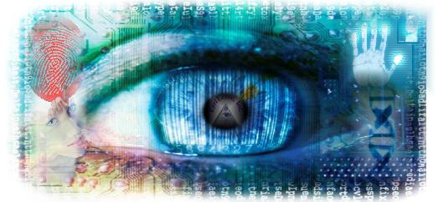
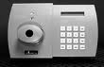
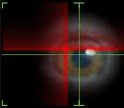

3.5) FACE RECOGNITION
The ability to recognize people by their facial characteristics. The most advanced technology , which maps the characteristics of a person's face into a multidimensional face space. The computer can distinguish the same person with different appearances; for example, with or without glasses, change of hair style and seasonal skin color changes. It also uses in some secret agencies.
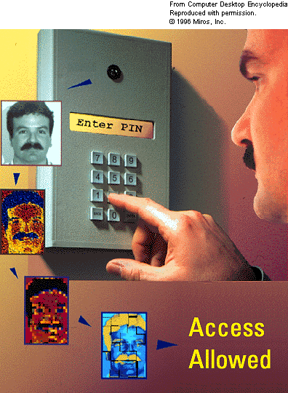

4) MIC/ HEAD PHONE
Both are input devices which are related to audio input. These device is used to enter sound in to the system for processing. It can be used in chatting, video conferencing, music or whenever we want to interact with the computer from voice input.
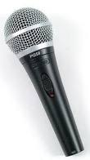
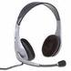

5) DIGITAL CAMERA
A digital camera can be used to take pictures. It can be hooked up to a computer to transfer the pictures from the camera to the computer. it use light sensitive processing chip to capture pictures or images
We can save these images where ever we want can be a CD, Computer disk, USB drive or can transfer from one computer to other computer or device.

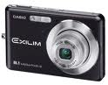

6) DIGITAL SCANNER
A scanner is used to copy pictures or other things and save them as files on the computer. A scanner is similar to a photocopier, except that instead of producing a paper copy of the document you place on it, you get an electronic copy which appears on your computer screen. This is very important input device use to convert a hardcopy file (printed paper) to a softcopy (image or display file).

